

Dr. Troy, Schmidt inc.

2019-03-13

Dr. Schmidt

963 Noah Terrace, South Ashleyfort, RI 75755

Phone: 8839023318

Fax: 5371236889

**Re:** Gina, Romero

**PHN:** 534911592

**Birthdate:** 08-Nov-1992

**Address:** 57035 Kathryn Isle, Fredview, TX 82768

**Patient number:** 6923235440

To Whom It May Concern:

This is a medical letter to state the above patient is pregnant with expected delivery date of 25-Feb-2025. Hoping this information is satisfactory for your requirements.

Thank you.

Sincerely,

Dr. Troy, Schmidt

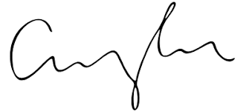

FRCS© NCMP

Clinical Assistant Professor, UBC

Department of Obstetrics and Gynecology SMH